San Jose State University

EE250 (Section 2) Fall 2019 Prof. Kamali

Solution to Problem Set #9

- Problem 9.46
a) 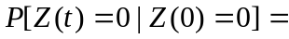 P[even # transitions in [0,t]]=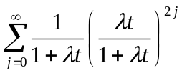
= 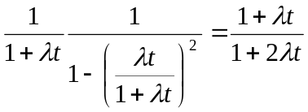

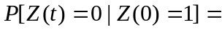 P[odd # transitions in [0,t]]=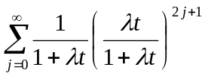
= 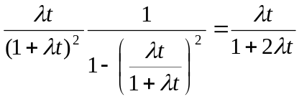

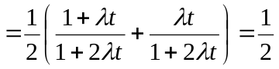

b)

- [Final Exam, Fall 2008] Consider the random process 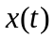which is defined in the following figure where 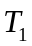 and 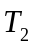are independent uniform random variables in 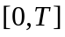. Find 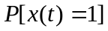for 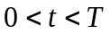.

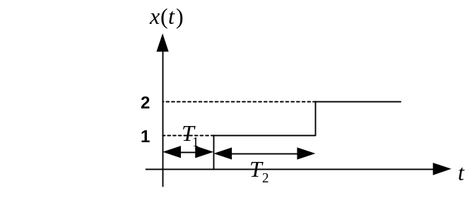
Solution:
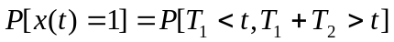

This area is shown in the following figure.

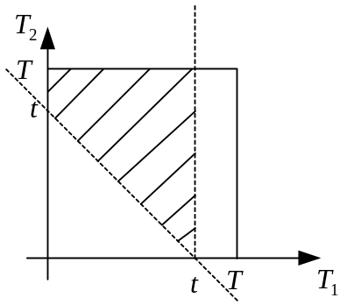

The area is easily calculated as 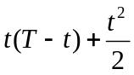 and thus

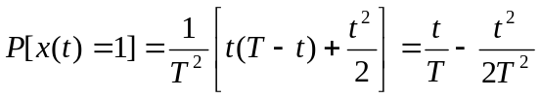

- [Final Exam, Fall 2008] Suppose is an exponential random variable with parameter. The parameter, however, is random itself and can take on the value of 1 and 2 with equal probability. Find the pdf of (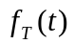).

Solution:

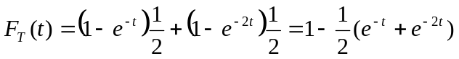

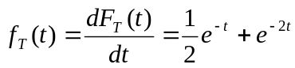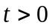

- [Final Exam, Spring 2005] Suppose is a Wiener process with parameter 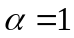. Find 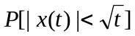.

Solution:
We recall that at any given time , is a Gaussian random variable with zero mean and variance of 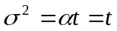. Therefore

- [Final exam, Spring 2015] Suppose 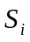 (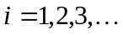) are the arrival times of a Poisson process with the average rate of 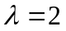 and 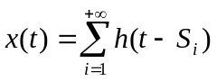where 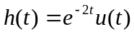.

- Find 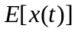.
- What is the limit of when 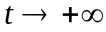.

Solution:
- Clearly is a shot noise process and thus

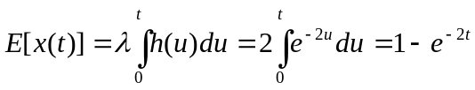

- 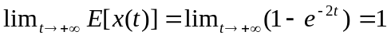

- [Final exam, Fall 2015] A continuous-time random process 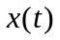starts at 0 at 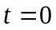and alternates between 0 and 1 every time a Poisson event with average rate of occurs (following figure).

- Find 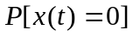 .
- Find 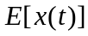 .
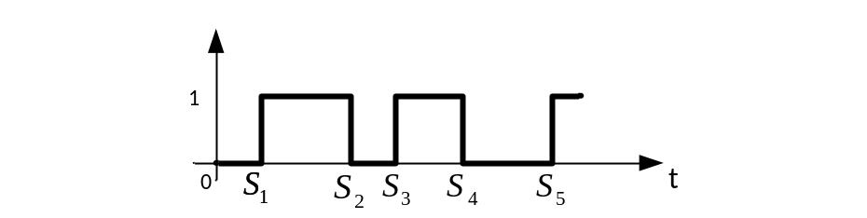
Solution:

- 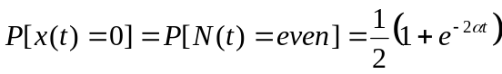
- 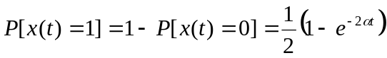
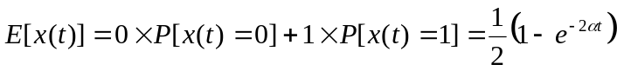

- [Final exam, Fall 2017] Consider the random process 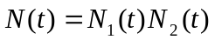 where 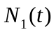and 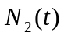 are two independent Poisson random processes with average rates of 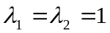.

- Does 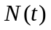have independent increment property?
- Find 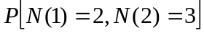.

Solution:
- Yes. We note that 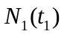is independent of 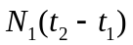due to the independent increment property of . Furthermore is independent of 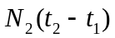because and are independent. Similarly 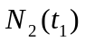is independent of both and . Thus the product of 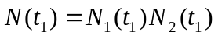will be independent of 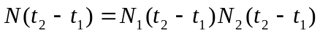 which proves that has independent increment property.

- Using the fact that has independent increment property, we have

